
Tuart Hill Primary School
Est. 1910


Banksia St Tuart Hill WA 6060
Ph: 9413 1500
Email: TuartHill.PS@education.wa.edu.au TuaTuartHillTuartHill.PS@det.wa.edu.au


Creating Bright Futures

Kindergarten and Pre-Primary
Parent Information 2024



OUR VISION
To provide a safe and caring environment in which we are constantly striving for excellence while preparing our students for the challenges of an ever-changing world.

OUR MISSION
At Tuart Hill Primary School, we:
- Foster a love of learning.
- Encourage students to reach their potential with innovative teaching practices that recognise their individual needs.
- Provide a positive environment that promotes excellence and offers support in all learning endeavours.
- Promote and celebrate the cultural diversity of our school.
- Develop resilience, adaptability, and critical thinking.
- Use our core values to help develop creative, connected, caring, and committed citizens.

OUR VALUES
Learning We believe that: | Excellence We believe in: | Care We believe in: | Equity We believe in:
- All students have the capacity to learn.  - Quality teaching is one key to learning achievement.  - A whole school approach to curriculum areas is the best way to achieve positive outcomes.  - Sustainability and ICT should be imbedded in our teaching and learning practices.  - Using quality data to drive school planning helps improve student achievement | - Setting high expectations for staff, students, and the community in all areas of teaching and learning.  - Setting high expectations for students to strive to achieve the very best academic and social outcomes.  - That all parents have a responsibility to support teachers and students in their pursuit of excellence.  - Embracing innovative practices to enrich teaching and learning at our school.  - A planning, teaching and assessment cycle.  - Celebrating the achievements of our students, staff, and community. | - Providing a safe and supportive environment that is respectful, honest, and friendly, and that instils a sense of pride in our school.  - Working in a collaborative manner across the school community to make the most of individual strengths and help every child achieve.  - Fostering clear and open lines of communication between parents, students, and teachers to provide better outcomes for everyone.  - A high level of professionalism including observing a community wide code of conduct | - Ensuring an equitable school that respects the individuality of all children and adapts teaching to their needs.  - Celebrating the rich environment of our culturally diverse school and allowing all voices to be heard with respect.  - Always following the professional standards in our staff code of conduct.  - In abiding by the student code of conduct at all times.  - Fostering positive relationships and partnerships that enable our school community to achieve the very best outcomes for everyone.

INTRODUCTION
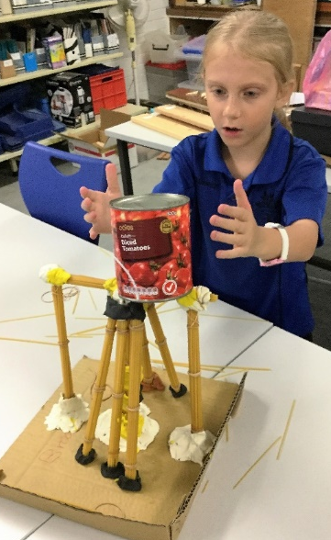
Tuart Hill Primary School is an independent public school, enabling our community to have greater flexibility and accept higher accountability when we make decisions about curriculum, student support, staff recruitment, financial management and governance.
Tuart Hill Primary School was opened on the 25 April 1910 in the suburb of Tuart Hill, five kilometres northwest of the Perth CBD. The main school buildings were constructed in the late 1940s and our most recent building opened in 2010. The school has a purpose-built kindergarten/pre-primary and library. Our school hosts the permanent Dental Clinic that is accessed by students from nearby schools. The Tuart Hill Community Kindergarten is located approximately 800 metres off site and is closely linked to our school.
Specialist programs currently provided to students include LOTE(Spanish), Physical Education, Visual Arts, Music, Technology and Science as well as support being provided for environmental programs and Technologies. Our staff are digitally literate and use interactive whiteboards, iPads, laptop, and desktop computers to enhance rigorous learning and teaching programs.
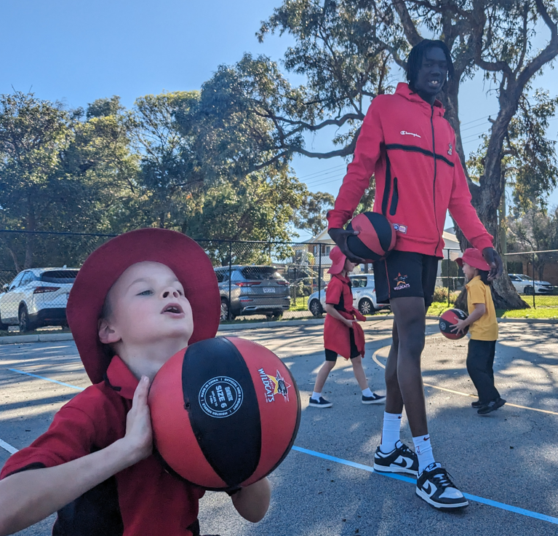
The school appreciates our three large play areas that include AFL and Soccer ovals, multipurpose refurbished hardcourts, and varied playground equipment. We believe in the value of natural elements in play spaces, and strive to provide a challenging, inclusive variety of activities that inspires our diverse student population.
Approximately 38% of our students come from a language background other than English with over 33 different first languages. All staff are committed to helping students reach their full potential through the development of a curriculum that caters for the needs of all individuals. At Tuart Hill Primary School, we believe parental support is critical if students are to reach their full potential. We actively promote our school in the wider community and encourage parental input into how our school operates.
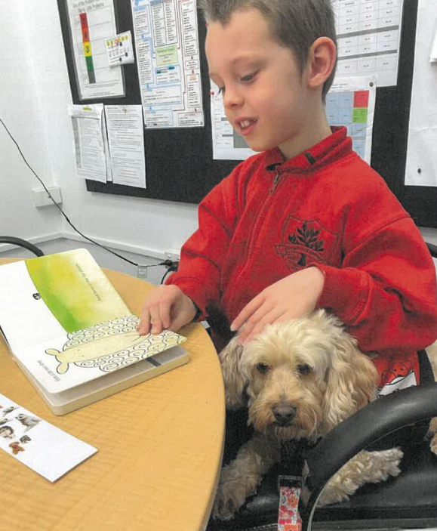
Tuart Hill Primary School enrolments indicate an upward trend, indicating that we are the school of choice for all within our school boundaries. The quality of all staff who support our students is matched with positive teaching of an appropriately differentiated rigorous curriculum. This is resulting in high community confidence in our school’s ability to care for, support and challenge their children so that they are well-prepared to continue their learning journey into Secondary School and beyond.
Student progress is our ultimate goal which we take very seriously. All staff at Tuart Hill are accountable for the progress of our students and for their performance as administrators, teachers, and support staff. Through effective Performance Development and Accountability Management processes, staff at Tuart Hill Primary School reflect on what they do well and how they can further develop, to improve student outcomes across the school.
At Tuart Hill Primary School, we believe that parent support is critical if students are to reach their full potential. For this reason, we actively promote our school in the wider community and encourage parent input into how our school operates.
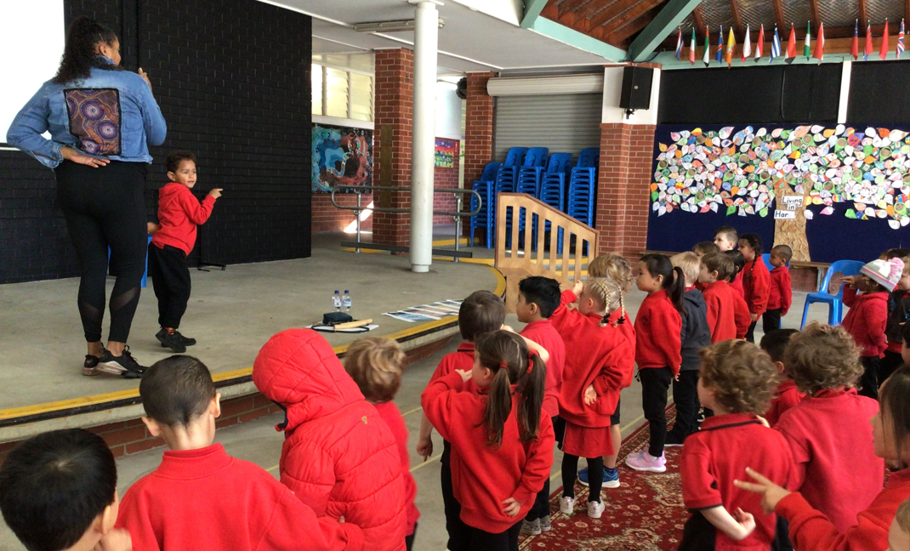
We are thrilled you have chosen us as your school, and we look forward to walking your child/ren’s educational journey with you. Please refer to our website https://tuarthillps.wa.edu.au frequently – we post updates regularly and intend that our parents will find the answer to any school-based query online. Parents are welcome to contact me beverly.innes@education.wa.edu.au at any time.
Kind regards,

Beverly Innes
Principal
Excellence Care Equity Learning
At Tuart Hill we strive to ExCEL

PHYSICAL SETTING
Teaching Areas are divided into three sections:
- Pre-Primary and Kindergarten
- South wing: Junior Primary
- North wing: Middle/ Senior Primary
- Art Block – Arts and Music/ Senior Primary
There is also:
- Library, staffed with a fully qualified Library Officer
- Dedicated Music and Drama Specialist classes in a fully equipped Music room
- Dedicated Visual and Media Arts Specialist classes in an innovative, purpose-built Art room
- Refurbished Science room enabling specialist Science classes and STE(A)M integrated learning opportunities
- After School Care - On site Mulberry Tree Kids Club (9345 2211)
- Off site – Tuart Hill Out of School Care (0414 838 928)
- Canteen staffed by a qualified chef, coordinated and supported by our active, dedicated Parents and Citizens (P&C) Association and willing Volunteers
- Enclosed undercover area (Hall)
- Onsite self-contained fully operational Dental Clinic staffed by qualified Dentists and Therapists through the Department of Health
- Stephanie Alexander Kitchen and Garden
Our school believes in supporting all our students to use IT as a learning tool. Classrooms have access to laptop computers which are connected via a wireless network. The students have access to Laptops, Netbooks and iPads in their classrooms.

The grounds are large with multi-sports courts and three distinct play areas comprising playground equipment and grassed areas.

SCHOOL BOARD
The School Board consists of a maximum of seven parent representatives, three community representatives, four staff representatives (elected annually by the school staff) and the Principal.
The functions of the Board are to take part in:
- Establishing and reviewing from time to time, the school’s objectives, priorities and general policy direction.
- The planning of financial arrangements necessary to fund those objectives, priorities and directions.
- Evaluating the school’s performance in achieving them; and formulating codes of conduct for students at the school
- Determining, in consultation with students, their parents and staff, a dress code for students when they are attending or representing the school.
- Promoting the school in the community.
- Approving:
  - Charges and contributions for the provision of certain materials, services and facilities.
  - Extra cost optional components of educational programs.
  - Items to be supplied by a student for personal use in an educational program.
  - Any agreements or arrangements for advertising or sponsorship in relation to the school.
You can read more about the School Board at https://www.education.wa.edu.au/school-councils-boards.

OFFICE HOURS
The School Front Office is open Monday to Friday from 7.30 am to 3.30 pm.
Please call: 08 9413 1500 email tuarthill.ps@education.wa.edu.au SMS absences to 0417 931 262

TERM DATES FOR 2024
TERM 1: Wednesday 31 January to Thursday 28 March
TERM 2: Monday 15 April to Friday 28 June
TERM 3: Monday 15 July to Friday 20 September
TERM 4: Monday 7 October to Thursday 12 December

SCHOOL DEVELOPMENT DATES 2024 - students do not attend school on these days.
The School Development Days are pupil free days that school staff value as opportunities to collaboratively plan whole school directions, reflect on data to inform future actions and to participate in professional learning.
The School Board has approved the following School Development Days for 2024:
Term One 2024 | Term Two 2024 | Term Three 2024 | Term Four 2024
- Monday 29 January  - Tuesday 30 January | - Friday 26 April | - Friday 16 August | - Friday 13 December
These dates may change to suit the strategic needs of the school; please refer to the eNews for updates.

SCHOOL TIMES
*Kindergarten Attendance Pre-Primary – Year 6 Attendance
School commences | 8.40am
Lunch | 1.10pm - 1.50pm
School finishes | 2.45pm
School commences | 8.40am
Lunch | 1.10pm – 1.50pm
School finishes | 2.50pm

*Group A attend Monday, Tuesday and alternate Wednesdays (odd weeks)
*Group B attend Thursday, Friday and alternate Wednesdays (even weeks)
*Group C attend Monday, Tuesday and alternate Wednesdays (odd weeks)
*Group D attend Thursday, Friday and alternate Wednesdays (even weeks)

Arrival time for school
Please ensure your child arrives promptly at the beginning of the day to avoid interruption to the class program. All teachers open their doors to help transition students from home to school from 8.30am. Teaching commences at 8.40 am – your child misses out if they are late for the start of the day, not only educationally, but also organisationally and socially. I am available beverly.innes@education.wa.edu.au for a deeper chat regarding the wide-ranging consequences of students being late to class
Teachers at Tuart Hill Primary School accept duty of care for their students at 8.30 am. Parents/carers are encouraged to engender appropriate independence and acceptance of responsibility in their children by allowing them to prepare themselves for the school day – please liaise with your child/ren’s class teacher to find out the established morning routines and support your child to carry them out (without doing the tasks for them).
Parents/carers are requested not to bring children earlier than 8.15 am. An adult is required to wait in the Hall with your child until 8.30am. Parents/carers must escort their child to Kindergarten or Pre-Primary to deliberately pass the duty of care from you to the educators.

First Day Tips
Introduce your child to a staff member. They will be given a name tag and shown where to hang their bag. Lead your child to an activity and stay for a little while. When you are ready to go, say “goodbye” and leave. If your child cries take them to a staff member but leave quickly. Children not used to leaving their parents may initially find the parting difficult but prolonging the moment only makes it worse. Children may cry for a short time but soon settle down to the business of enjoying themselves and socialising with other children. If you are worried or anxious, please ring the school and we will let you know how your child is getting on.
End of school day
Students are to be collected promptly at the end of the school day – Kindergarten at 2.45pm and Pre-Primary at 2.50 pm. Young children may become upset quickly if they are collected late. Children who have not been collected within 10 minutes of the 2.50pm final siren will be required to wait in the front office from where they will be handed over to their parent/carers and the pickup time recorded. It is expected that this would only occur when parents have been unavoidably detained. NO child will be permitted to leave the school unaccompanied or with a person other than his/her parent or legal guardian unless written permission is given to the teacher or Front Office beforehand.
We value opportunities for our parents to make links with each other and are pleased that families may linger for a few social minutes after school. In such circumstances, parents hold duty of care for their children. All people are expected to observe our School Expectations. The Siren will sound at 3.15 pm to alert parents that the school perimeter gates are about to be locked –usually at 3.30 pm. Please move promptly off the school grounds, thank you.

Tuart Hill Primary School Expectations
Purpose Statement
The Tuart Hill Primary School PBS team will guide the whole school community
to develop a common understanding of expected behaviours and
how to explicitly teach and reinforce these through positive interactions.
This will create a community that works together to promote learning, excellence, care and equity.
Our Values
Learning  Self-discipline  Co-operation  Responsibility  Trust | Excellence  Perseverance  Confidence  Enthusiasm  Commitment | Care  Respect  Courtesy  Consideration  Friendliness | Equity  Fairness  Generosity  Humanity  Empathy
Our Expectations
Whole School and Community
To demonstrate learning we….  - Take responsibility for our own behaviour  - Follow staff instructions promptly and respectfully | To demonstrate excellence we...  - Attend school regularly  - Contribute positively to school community events  - Take pride in what we do and celebrate our achievements | To demonstrate care we…  - Are kind to all  - Respect school property and equipment  - Look after our environment  - Move safely around the school | To demonstrate equity we…  - Respect the diversity of our community  - Be positive role models to help ourselves and others succeed  - Show sportsmanship
Classrooms and Learning Areas
To demonstrate learning we….  - Arrive at class on time ready to learn  - Listen attentively  - Are curious and ask questions  - Allow others to learn | To demonstrate excellence we...  - Participate actively and positively  - Work cooperatively with others  - Persevere when faced with challenges | To demonstrate care we…  - Speak and act with consideration  - Respect the opinions of others  - Support the learning of others | To demonstrate equity we…  - Include others  - Allow others to contribute  - Disagree respectfully
School Grounds and Play Areas
To demonstrate learning we….  - Co-operate with others  - Include others  - Care for the playground and garden | To demonstrate excellence we...  - Play safely and sensibly  - Follow game rules  - Assist others | To demonstrate care we…  - Wear sun safe hats  - Care for and return sports equipment  - Leave areas neat and tidy | To demonstrate equity we…  - Consider the wellbeing of others  - Play fairly  - Share resources

PARKING
The P&C Parking Committee has been very pleased to work closely with the City of Stirling Road Safety Officers to do all we can to keep our children and parents safe during times of high congestion around our school.
Banksia Street
- Wheelchair Access Bay has been positioned close to the main school entrance. Please always respect this bay; thank you.
- Staff use the south gate to enter and exit the Staff Car Park. Please watch for exiting vehicles.
- The north gate is now opened all day to facilitate pedestrian access especially for prams, pushers and wheelchairs but also to create an open welcoming entrance to our school. This entrance is strictly emergency vehicle and pedestrian access.
- Kiss & Drive has been established at the front of our school.
  - Parents are encouraged to ask their child/ren to wait at Kiss & Drive to be picked up.
  - Kiss & Drive will be supervised every day possible, ensuring child safety.
  - The driver must stay in the car at Kiss & Drive.
  - As students are collected, cars move down to the south end of Kiss & Drive to allow other cars to join the queue.
  - You may be asked to ‘go around’ if your child is taking a long time to come to Kiss & Drive and the queue to enter Kiss & Drive is impeding traffic flow. ‘Go Around’ means that you leave the front Kiss & Drive position, drive forward and either:
    - Go around the block - turn left at Cape Street, turn left at Acorn Lane, turn left at Lawley Street, turn left at Banksia Street to re-join the queue – your child might be waiting for you by then; or
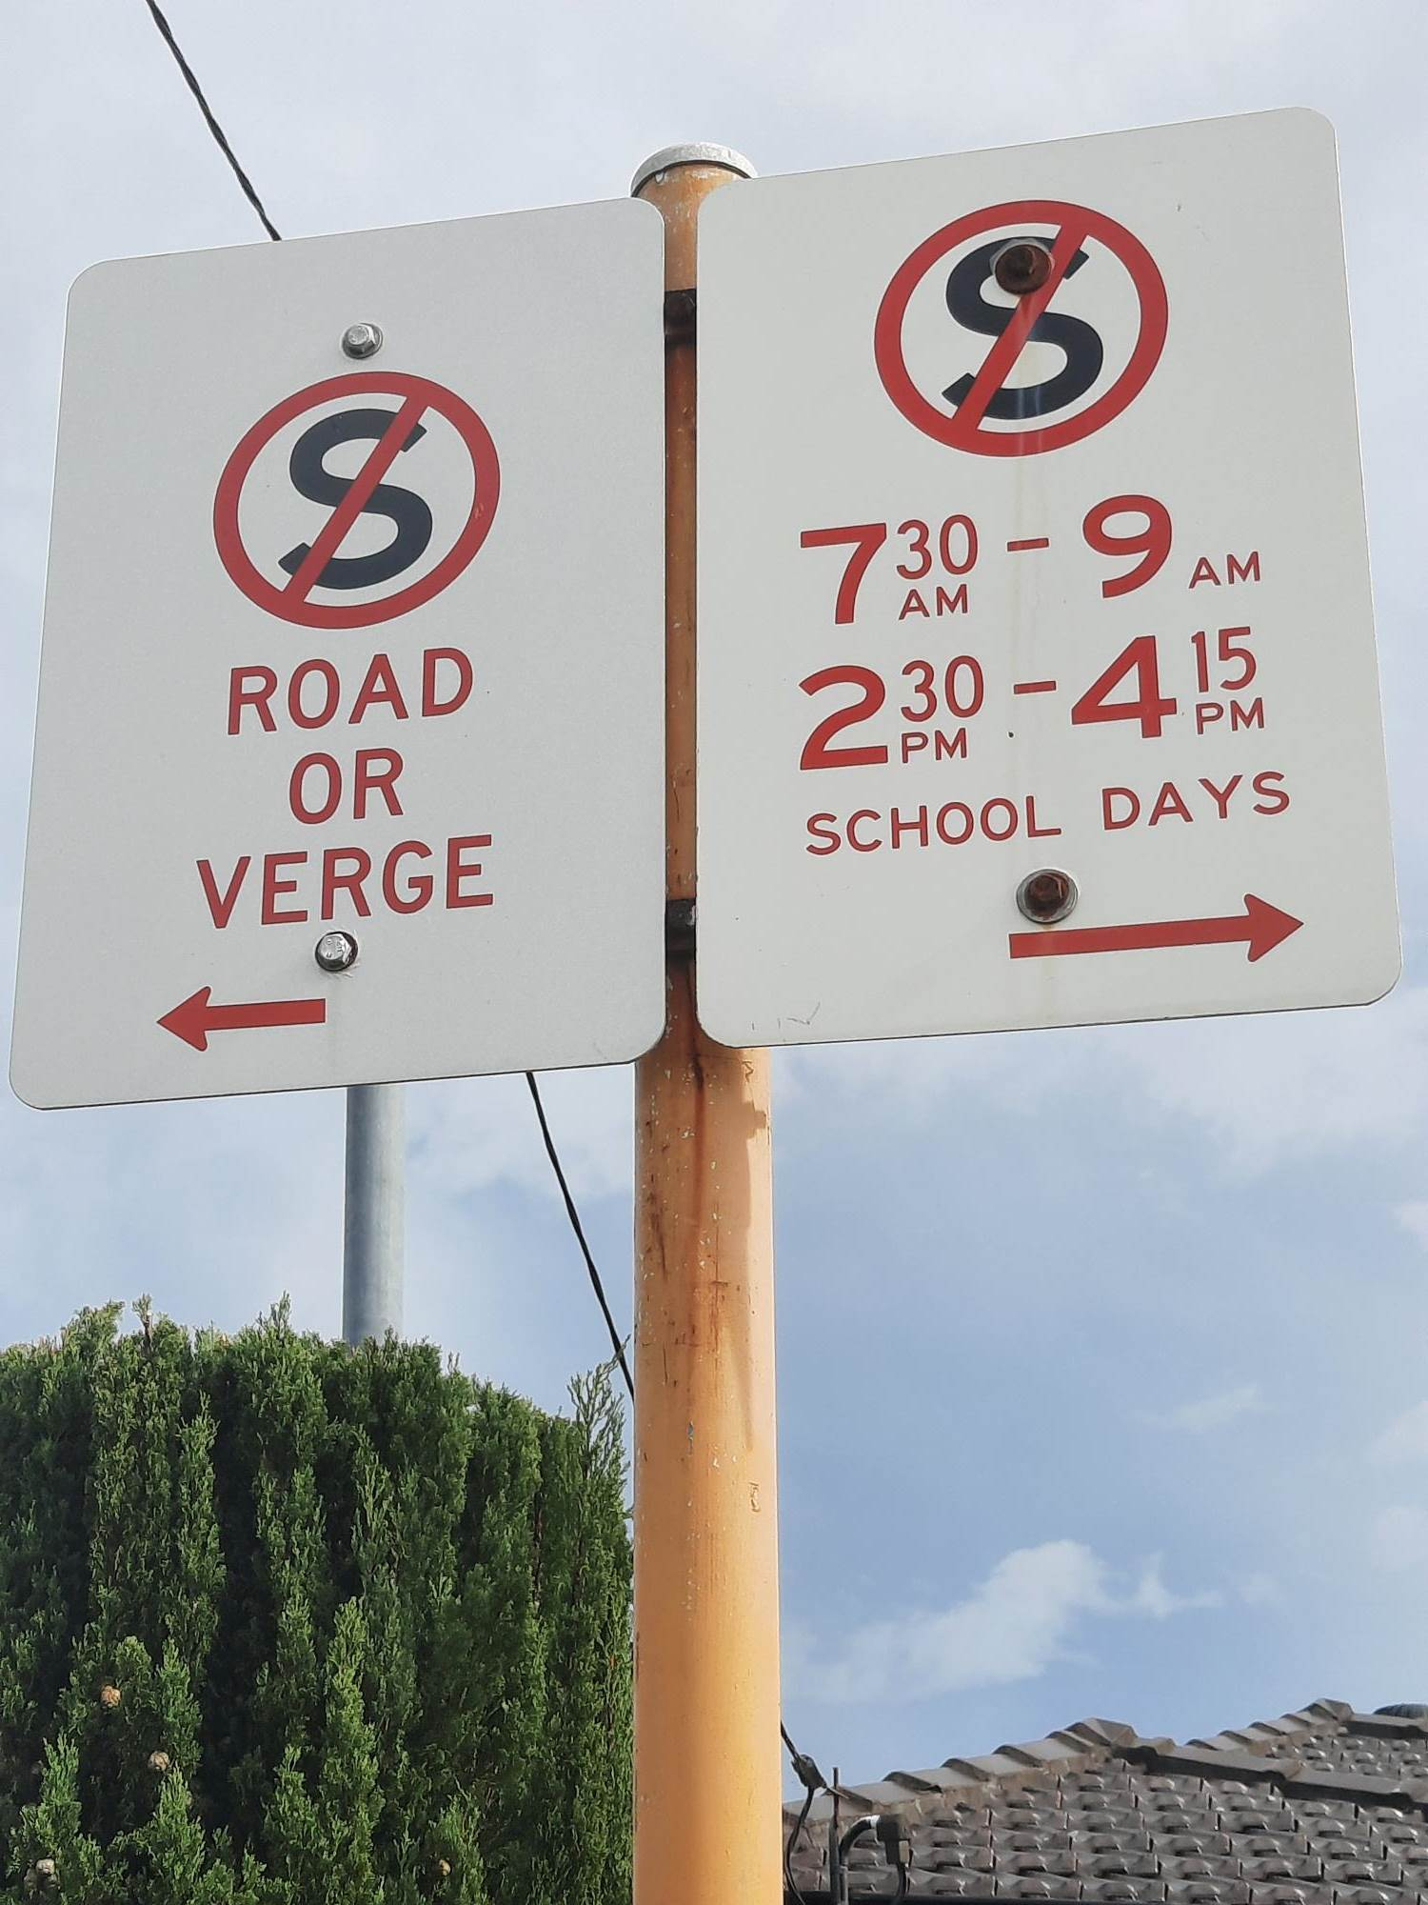
    - Go all the way around the roundabout back onto Banksia Street driving North, turn left at Riley Street, turn Right at French Street, turn right at Lawley Street, turn right at Banksia Street to re-join the queue – your child might be waiting for you by then.
- Street signage reflects parking conditions. Please read these signs as illegal parking may attract a fine.
- Parents may not park on corners nor on the west side of Banksia Street. Yellow lines have been drawn to clearly show this road rule, and signs have been refreshed. Parents risk a fine if they ignore the signage. Banksia Street must remain a two-way street, with unimpeded traffic flow both north and south along the street. Parking on the road is illegal. Please, park in marked bays; thank you.
- U-turns are not permitted on Banksia Street. Please go around Riley Street, French Street, Lawley Street to join Kiss & Drive; thank you.
Cape Street
- Car parking spaces have been clearly marked along Cape Street to maximise effective use of the space.
- Street signage reflects parking conditions. Please read these signs as illegal parking may attract a fine.

Lawley Street
- The Wheelchair Access Bay has been positioned close to the Dental Car Park entrance. Please respect this bay at all times; thank you.
- Parents may not park on verges nor on the north side of Lawley Street. Street signage has been refreshed to reflect changed parking conditions. Please read these signs as illegal parking may attract a fine. Lawley Street must remain a two-way street, with unimpeded traffic flow both east and west along the street. Please, park in the marked bays; thank you.
- Pedestrian Access is to the west of the Dental Car Park gates and further east at the top of the multipurpose courts. Please model safe habits by walking your family either west or east of the Dental Car Park; thank you. Pedestrians in car parks are a danger too serious to contemplate.
The Parking Committee’s aim is to ensure the safety of the whole community, to respect nearby property owners, to facilitate traffic flow, to increase car parking spaces and to be within the law. The Committee acknowledged the extremely positive involvement our parents have as we all work in partnership to ensure the best education for every student at our school; and wanted to ensure we supported not only parents who need a speedy drop-off and collection, but also those who wish to walk in for a chat with the teachers, to catch up with friends, to volunteer in the canteen/ uniform shop/ library/ parent help.
The Parking Committee remains active in responding with adjustments that will continue to facilitate our highly valued community involvement. Parents are welcome to email the PandCthps@gmail.com or beverly.innes@education.wa.edu.au - or catch me for a chat ☺.

PARENT RESPONSIBILITIES
Full cooperation between parents and teachers is essential for students to make good progress and to achieve both socially/emotionally as well as academically. Please assist staff by:
  - Informing the school of any change in address and/or phone number and emergency contacts.
  - Discussing with staff any information that may help us understand your child better.
  - Keeping in touch with the teacher on matters concerning your child’s health and well being.

CRUNCH AND SIP, RECESS, LUNCH – Food at School
Please ensure recess snacks and lunches contain healthy foods – do not provide chocolate, pre-packaged salty chips/Twisties, sugar-dense foods. Take-away foods are inappropriate for school, including hot chips. Chewing gum and lollies are strictly banned at our school and will be confiscated. Parents may collect confiscated items directly from the admin member involved.
The school Canteen supplies a range of food, snacks and drinks at reasonable prices. Families may order lunch from the Canteen - an up-to-date menu is available on our website, as well as links to order and pay online: https://quickcliq.com.au . The canteen operates four days a week - Tuesday, Wednesday, Thursday and Friday - and is operated by the P&C. Students are also invited to place a lunch order with Jodie at the Canteen before school from 8.30 am. Correct payment is recommended; thank you. The Canteen always welcomes parent help for one or two hours – connect with the Tuart Hill Primary School Parents and Citizens Facebook page to keep in the loop and to stay informed.

Crunch and Sip is a teacher-initiated break for students to eat fruit or salad vegetables and drink water in the classroom. This concept has been introduced to support students to support effective brain function during lessons, increase the opportunities for students to drink water during the day and to establish healthy eating habits whilst at school. Would you please send along ONE piece of fruit or veg with your child each day in a labelled container, separate to their lunch box? If your child is allergic to any foodstuff, it is critical that you notify us. All children should bring a drink bottle containing water daily. This is kept inside the classroom and can be accessed at any time. Please label all containers including lids with your child’s name. For further information, including suitable Crunch and Sip foods, visit https://www.crunchandsip.com.au .

Some students love to celebrate their birthday at school. If you would like to send something to share, a simple pre-cut cake or small cup cakes are most suitable. We do not allow lollies/chocolates to be shared at school. Party Bags are distributed at the end of the school day so that parents may supervise what their child consumes. Please liaise closely with your class teacher to find out how birthdays are acknowledged in the classroom. Remember to ask your child’s teacher how many children are in the class so there is enough for everyone.
We are a nut-aware school – it is important that no nut products are included due to our high awareness of food allergies. There are lots of stunning recipes available online that are allergy friendly.

DRESS CODE / UNIFORM
Dress code requirements: red school shirts or red polo shirts; black bottoms. No slogans or multi-coloured designs.
- Denim clothing is not permitted
- Red school jumpers (with school logo), or red windcheaters.
- Black trousers / tracksuit / shorts / skirt / skort
- Leggings must be worn with shorts / skort / skirt / dress
- School dress or red and white checked cotton dress
- Appropriate footwear, preferably joggers/sneakers, that strap to your child’s feet, i.e. No thongs, massage sandals, rain boots, Ugg boots, high heeled sandals or shoes.
- Plain socks – black or white – are preferred.
- No jewellery is preferred. Earrings must be studs, for safety reasons.
- Makeup for students at school is never appropriate. Parents may be asked to attend school to remove makeup.

Please ensure that your child can cope with zips and buttons on clothes to avoid toilet accidents. A complete change of clothes should be left in your child’s classroom in case of accidents. All items of clothing, which are removable should be clearly and permanently marked with the name of the owner.

Footwear
Sneakers are recommended as the most practical footwear option. All children are required to wear shoes at all times for safety reasons. Please try to put ‘manageable’ shoes on your child. Ankle-strapped school sandals may be worn during summer – no thongs please. Please teach your child to tie their own laces or supply shoes with Velcro fasteners.

Modifications to the Dress Code
Parents who may wish to modify the school dress code for religious or health reasons must make an appointment to discuss such modifications with the principal beverly.innes@education.wa.edu.au . Staff will be informed of any student granted a modification to the dress code.
Students not following the dress code will receive:
- counselling from Administration on the benefits of a dress code.
- assistance/support in obtaining suitable clothing, if necessary.

Parents will be contacted to support families to provide their chid/ren with clothes that comply with the Dress Code. Students not following the dress code may be denied the opportunity to represent their school at school activities.
Hats
The school has a Hat Policy that has been endorsed by the School Council and requires that students wear a sun-safe broad brimmed hat whilst out in the open all year. Expectation is that students will wear the approved school hat. Parents are responsible for providing this item. Students not wearing the approved school hat may be denied the opportunity to represent their school at school activities.
Lost Property
Please label all student items including clothing, lunch boxes and water bottles. Lost property can be located under the notice board next to the canteen. Please check there for any missing items.
Personal property
Children are asked not to bring personal effects to school, i.e. jewellery, sporting gear, expensive toys, electronic games etc.
Student mobile phones
Children are not permitted to use mobile phones during the school day. If your child needs to bring a mobile phone to school, these must be clearly labelled, switched off and handed in to the Front Office before school. It is the student’s responsibility to retrieve their phone from the Front Office after school.

ABSENCES FROM SCHOOL
If your child is to be absent for the whole day you are required by the Department of Education to notify the school, either by phone on 9413 1500 or the school’s SMS 0417 931 262. Notification may also be sent using an online form available at https://tuarthillps.wa.edu.au/information/student-absence .
Vacations During the School Term
Under the Department of Education guidelines, the Principal cannot approve student absence for the purpose of family holidays. As such, in-term holidays are not supported by the Department's Student Attendance Policy and Procedures 2015.
The School Education Act 1999 requires students to attend school, or participate in an educational program of the school, on the days on which it is open for instruction. A student may be excused if they are prevented from attending due to temporary physical or mental incapacity, or other reasonable cause. Parents are required to notify the school of the reason for each absence as soon as practical, and at least within three days of the commencement of the absence (Sections 23 - 25).
There is no requirement within the School Education Act 1999 or School Education Regulations 2000 for schools to provide a work package. At this school this is at the discretion of the teacher, and you will need to contact the teacher direct if you would like to ask for your child to receive a work package.
Please see further information on the School Education Act 1999 and Department policies on the Department of Education’s website.
EMERGENCIES
Parents are asked to make sure that their home address and telephone number and their emergency address and telephone number on admission cards are kept up to date. Wrong information can cause unnecessary delay in seeking medical attention. Should any contact detail change, please call the Front Office 08 9413 1500 or email tuarthill.ps@education.wa.edu.au with your child/ren’s names and the information you need changed; thank you.
Please keep all medical conditions relating to your child/ren up to date – both with class teacher and on admission cards.
Working parents are also requested to keep the school informed if their employment changes including new contact details of the place of employment, in case of emergency.

SICK CHILDREN
WE RECOMMEND YOUR CHILD STAYS AT HOME IF…
THEY HAVE  A FEVER | THEY ARE  VOMITING | THEY HAVE  DIARRHOEA | THEY HAVE  A RASH | THEY HAVE  HEAD LICE | THEY HAVE AN  EYE INFECTION | PLEASE SUPPLY DISCHARGE PAPERS FROM HOSPITAL OR DOCTOR FOR ANY COMMUNICABLE DISEASES
 |  |  |  |  |  | 
Temperature of 38 or more | Within the past  24 hours | Within the past  24 hours | Body rash,  Sores or itching | Itchy head,  Active head lice | Redness, itching, dripping from the eye | Hospital stay or treated by medical profession
YOUR CHILD IS READY TO RETURN TO SCHOOL WHEN…
Free of fever | No more vomiting and I’ve had at least two meals without getting sick | No diarrhoea | No more itching and the pharmacy or doctor have cleared it as not being contagious | Treated and cleared with evidence | Treated and cleared by pharmacy or doctor with evidence | Treated and cleared by pharmacy or doctor with evidence
CONTAGIOUS DISEASES ARE SPREAD THROUGH GROUPS OF PEOPLE VERY FAST
THANK YOU FOR SUPPORTING THE SCHOOL IN BEING
PROACTIVE AND VIGILANT AROUND INFECTIONS

WE ARE A COMMUNITY, WORKING TOGETHER TO PROTECT OUR CHILDREN AND TEACHERS

Medication policy
Teaching and support staff do not administer medication. If your child needs to receive any medication during school hours, please discuss this with front office staff. There are Department of Education processes to be followed and forms to complete as part of the school’s duty of care towards your child.
Student Services
The Associate Principal can support parents with all matters regarding Student Services. We have several professional support staff who visit the school on a regular basis. If you have any special concerns regarding your child/ren, please contact your child’s teacher, who will support you to liaise with Mrs van der Wal.
- Nurse A community nurse will be visiting the school on a regular basis during the year. She will be screening all pre-primary and Year 1 children who have not been previously assessed. Teacher and parent requests will be met for all other years. Parents will be contacted by the nurse should any referrals be necessary.
- Educational Psychologist: An Educational Psychologist attends the school and works as a member of the school team to evaluate and assist with any difficulties students may have. Parents are advised to contact their child’s teacher to discuss any concerns.
Dental Therapy Centre
Consent forms will be issued sometime after enrolment at school. Parents will be advised of appointment times.
Telephone: 9344 1585 Hours: Monday to Thursday: 8.15am – 4.30pm
Friday: Closed

PHOTO PERMISSION FORM
As part of the enrolment package students will receive a Photo Permission Form which needs to be signed by a parent and returned to school. The form gives the school permission to use images of your child on the school intranet/website and publish their name or work in the school newsletter. Students are only identified by their first name if identification is necessary. Please feel comfortable asking to discuss photo permission with the Principal Beverly Innes beverly.innes@education.wa.edu.au if you have any queries; thank you.

LIBRARY
All children in every class in the school are encouraged to borrow books from our school library. A book can be “on loan” for one week. Students need a library book bag before they can borrow books from the library – please ask the class teacher about a suitable Library Bag if you are unsure.
It is important that our library books are valued and cared for, so others may borrow and enjoy them at another time. If a library book is damaged or lost, the family of the student who borrowed it will be asked to pay for the cost of a replacement. Please support the school by helping your child/ren treat our books with respect; thank you.
BOOK CLUB
To encourage leisure reading by students, ‘paper-back’ and ‘hard-back’ books are available twice a term from the Scholastic Book Club. Each child will receive a catalogue suitable for their age group from which they may make a selection – with your approval of course. Orders may be placed and paid online – instructions are clear on the Catalogue.

BOOKLISTS - Student Requirements
Booklists for the following school year are sent home around November of each year. The list will include the items that will be required for your child’s education in the following year. Please purchase every item as requested. Class teachers collaborate to ensure they only request the items that will be required, and it is hard for your child/ren if they do not have school equipment. Please see Beverly Innes if you need any part of the Student Booklists clarified, thank you.
Parents may purchase student requirements from any outlet; however it is recommended for ease that you purchase through the school using the Campion Education option. With this service you are assured of purchasing the correct equipment and textbooks for your child. Please clearly name all your child/ren’s requirements; thank you.
Please note that Kindergarten and Pre-primary classes use shared pencil/Texta tins, and parents need not name these items as the class supply is regularly replenished by the class teacher as needed.

SCHOOL CONTRIBUTIONS
A schedule of charges and voluntary contributions will be issued in Term 4 and payable the following year. The School Board has approved these charges and voluntary contributions.
We encourage all parents to pay the charges and contributions as all funds go towards the education of your child.
If you are having difficulty in meeting the costs, please do not hesitate to come into the school office and see our Manager of Corporate Services Ms Natasha Harlond natasha.harlond@education.wa.edu.au.as we can certainly come to a confidential arrangement.
Student accounts
Student accounts can be kept in credit. To achieve this, all outstanding charges must be finalised. You are able to place an amount of your choice ($10, $20, etc) on the student account, which can then be used for future school activities.

To access this credit, you will need to tick the box on the permission slip:

Payment Method – Debit student account
When the student leaves our school, should there be any credit still attached to the account, it can be transferred to a sibling, or a refund can be issued. Parents may receive a Student Account Statement by emailing our Manager of Corporate Services Ms Natasha Harlond natasha.harlond@education.wa.edu.au.
Money collection
All money should be placed into the clear box at the Administration desk first thing in the morning. Voluntary Contributions can also be paid at the office. Please place money into the envelope provided and fill in the details. Please send the correct money as change is not given.
The school offers EFTPOS and bank transfer as an alternative to cash. EFTPOS is available at the front office and to make direct deposit payments to the school, please use these account details:
Bank: Westpac Banking Corporation
Account Name: Tuart Hill Primary School
BSB: 036-053
Account: 920 622
Reference: Child’s Surname / Room No / Code
(E: Excursion / I: In-school Activity / C: Contributions / P: PEAC / S: SIM)
Example: Smith 9 E

P&C ASSOCIATION
The P&C Association is an extremely important part of our school. You will be advised of meetings via the school eNews and the school website and you are most welcome to attend. P and C meetings are usually held weeks 2 and 7 of a school term, on Wednesdays at 5.45 pm, in the School Staff Room. Connect with the Tuart Hill Primary School Parents and Citizens Facebook page to keep in the loop and to stay informed.

ASSEMBLIES
Our Junior Classes (Years 1, 2 & 3) and Senior Classes (Years 4, 5 & 6) have alternate Assemblies. Dates and times are regularly published in the eNews and on the school website. If your child is receiving an award at any one of our assemblies, you will be notified via SMS.

REPORTING TO PARENTS
Student Summative Reports are emailed home at the end of each semester. These detail the social and academic achievements of your child. Please remember to save your child’s report once you have downloaded it.
Our school works hard to keep parents informed around student progress and achievement. We welcome brief chats at the class door, but longer and more personal conversations require an appointment with your child/ren’s teacher/s. Teachers will contact parents for appointments if they wish to discuss anything to do with your child/rens educational progress, and you are of course invited to contact the teacher for appointments. Please take opportunities to have a look at your child/ren’s workbooks to get an idea of their presentation, achievement standard and progress.
Parents may email teachers on their work emails, however, please be cognisant that staff do not spend their days on email – they are teaching! Staff have been informed that they may take up to 48 hours to respond to an email; please make sure your email in not urgent. Urgent messages may be phoned through to the Front Office 9413 1500 – the staff will take a note to the teacher, or quickly deliver the message personally to your child.
Staff have been counselled that emails are for information, not conversation. Conversations must be held face to face – if you have a burning issue, please resist the temptation to be a keyboard warrior - make an appointment. Please ensure your email tone is professional. We all want the best education for your child – we have the same goal. Thank you for your ongoing cooperation.
Term One: You can expect to be invited to a Class Meeting one evening in Week Two or Three of the school year, where the class teacher will explain how they run things in their classroom, how home reading/spelling/ any other homework might work, what their expectations are for Student Engagement in their classroom, and how they would like you to contact them. You can also expect an opportunity for a one-on-one interview opportunity so that you can get to know your child/ren’s teacher and teachers can get to know you a bit more, to begin to establish that critical home/school partnership.
Term Two: Semester One Summative Reports will be emailed to parents Friday, Week Nine. If you need any part of the report clarified, please use Week Ten of the term to contact the relevant teacher; thank you.
Term Three: Our school plans to offer an Open Night, when all classrooms and Specialist rooms are opened for parents, siblings and perhaps extended family to come into classrooms, look through workbooks, check out wall work and be proud of your child/ren’s achievements. Parents may make their own Term Three appointment if they wish; teachers will contact you for private catchups when required as well.
Term Four: Semester Two Summative Reports will be emailed to parents Friday, Week Nine. If you need any part of the report clarified, please use Week Ten of the term to contact the relevant teacher; thank you.
The relationship your child has with their teacher is really important. Please work with us to facilitate a positive, caring and trusting connection, so that your child/ren will see their teacher as the person who can help them, no matter the situation. The Principal, Beverly Innes, may be another person you might like to chat with regarding your child/ren’s educational experiences. We work as a team here at Tuart Hill Primary School, for the benefit of each individual child. We know that when we work together, your child/ren will be the best they can, happy to attend school every day, accepting the challenges that come with experiencing an exceptional education. Our staff look forward to working with you to ensure your child achieves to their potential.

DONATION OF MATERIALS
The Early Childhood Classrooms appreciates donations of the following:
Good quality paper | Shoe boxes | Card
Fabric | Bottle tops | Buttons
Wrapping paper | Tinsel | Cereal boxes
Greeting cards | Corks | Ribbon and lace off-cuts
Clean meat trays | Cardboard tubes (not toilet rolls) | Magazines
Plastic punnets (tomato) | Cotton reels | Wool

If you have any up-cyclable materials you think the Early Childhood classrooms could use, please ask your child’s teacher if they would like to have them before you recycle them another way; thank you.

TRANSFER PROCEDURES
If children are transferring to another school, we would appreciate a few days warning so that personal items can be collected and library books etc returned. The new school will send a transfer note and we will then forward the appropriate records to them.

QUESTIONS / PROBLEMS / CUSTOMER FOCUS
If you have any matter which you feel the need to discuss, please contact your child’s teacher or the Principal. In some cases, parents discuss what they feel are problems with other parents but fail to notify the school. The quickest way to solve such problems is to get in touch with the school.
In short, if you are happy, tell your friends. If you are unhappy, tell us.
Thank you for selecting Tuart Hill Primary School as your school of choice. We look forward to sharing your child’s educational journey with you.

/tmp/lo/0000.doc
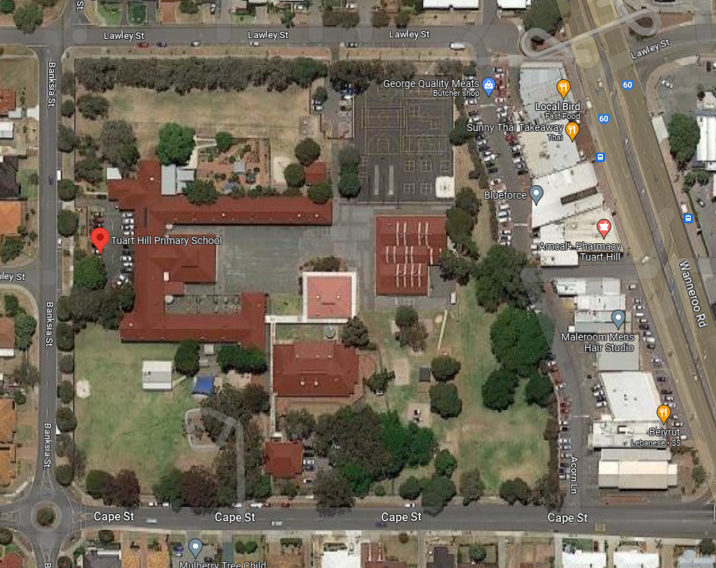

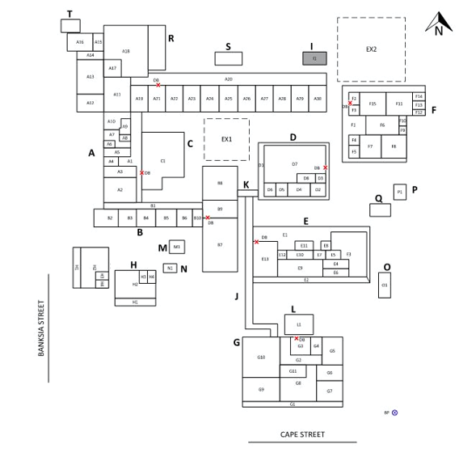

NOTES

