Dear Parent/Guardians,

Thank you so much for continuously supporting Tuart Hill P&C, especially through fundraising. We are excited to announce we are holding a Billy G’s Gourmet Cookie Dough drive as a major fundraiser this term. We are currently fundraising to upgrade the senior playground.

Billy G’s Gourmet Cookie Dough is an exciting fundraiser, made by an Australian, family owned and operated business. There are nine (9) dough-licious flavours to choose from, including the most popular Choc Chunk and Caramel White Choc. You can also create your own cookie magic with the Golden Classic flavour – the base of the Billy G’s secret family recipe. Billy G’s Gourmet Cookie Dough is exclusive to fundraising, so stock up! We are aiming to sell a total of 300 tubs.

Get started! Students will receive a Billy G’s Order Form with instructions on how to collect orders. Please note Billy G’s is a completely cashless fundraiser. All orders must be placed online and paid by credit or debit card or paypal, so make sure you create your online fundraising page today.

Start Date: 16 May
Final Orders Due: 29 May
Delivery Date: Tuesday 27 June – week 10 of term 2 – you will need to be able to collect your order from the school hall on this day. The cookie dough needs to be refrigerated so it is important you can collect or arrange someone to collect on this day.

How do we create a Fundraising Page? Creating a fundraising page is easy!
- Visit www.australianfundraising.com.au and click the “Cookie Dough Login” button on the home page.
Then click the register button to fundraise on the cybersafe, Billy G’s Cookie Dough platform.
Enter your child’s name, and search/select Tuart Hill Primary School and you child’s class number/name.
- Choose your goals and create a unique avatar!
- Place your order using the “Order Now” button and share your fundraising page with your family and friends via the “Share” section so they can start buying some yummy cookie dough. Easy!

How do prizes work? Every student who sells a tub will receive an incentive prize for their efforts! But why not aim higher? The more tubs you sell the more prizes you will receive! There are 12 prizes available, so set your own fundraising goal and aim for them all! Prizes are automatically ordered at the end of our fundraiser based on the number of tubs you have sold.

You can win Big! Our highest tub seller will go into a draw to win a $10,000 JB Hi-Fi Shopping Spree OR PlayStation 5 Gaming Bundle. Plus, every student that achieves all online virtual badges will win a Billy G’s Cookie Scented Plush Toy.

Happy fundraising,
Kate Hunt
Fundraising co-ordinator Tuart Hill PS P&C

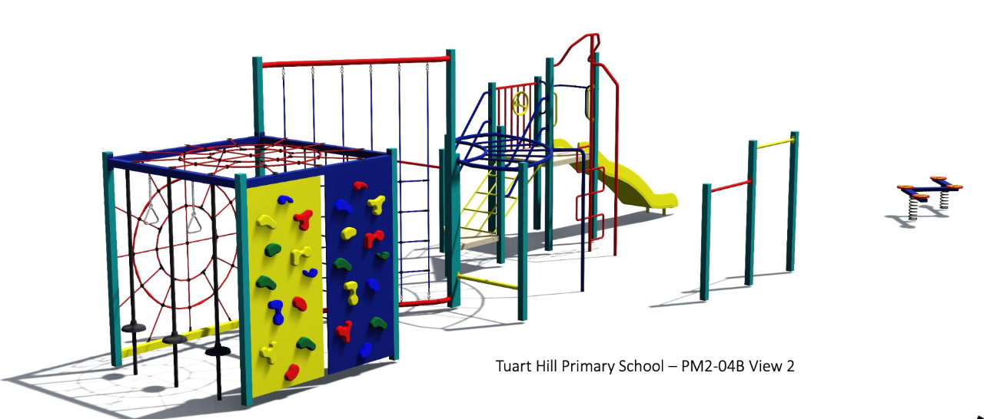

This is an artist’s impression of the play equipment we are fundraising for, in the senior play area.

